- Movie Datasite E-R Model

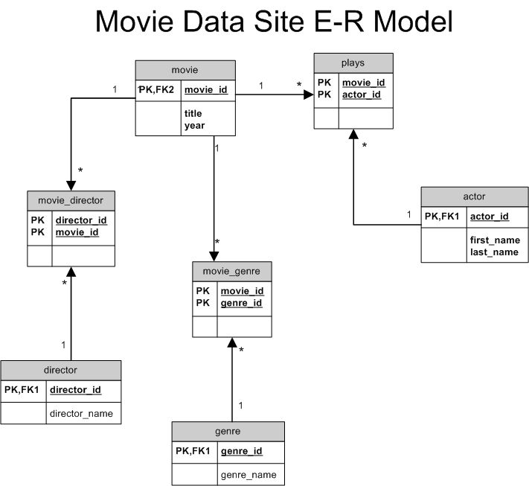

- Movie Datasite DDL Script
--Actor entity table
CREATE TABLE actor (
actor_id numeric(10) NOT NULL,
first_name varchar2(50) NOT NULL,
last_name varchar2(50) NOT NULL,
CONSTRAINT actor_pk PRIMARY KEY (actor_id)
);

--Movie entity table
CREATE TABLE movie (
movie_id numeric(10) NOT NULL,
title varchar2(200) NOT NULL,
year numeric(4) NOT NULL,
CONSTRAINT movie_pk PRIMARY KEY (movie_id)
);

--Association table between Actor and Movie entities
CREATE TABLE plays (
movie_id numeric(10) NOT NULL,
actor_id numeric(10) NOT NULL,
CONSTRAINT plays_pk PRIMARY KEY (actor_id,movie_id),
CONSTRAINT plays_actor_fk FOREIGN KEY (actor_id) REFERENCES actor(actor_id),
CONSTRAINT plays_movie_fk FOREIGN KEY (movie_id) REFERENCES movie(movie_id)
);

--Director entity table
CREATE TABLE director (
director_id numeric(10) NOT NULL,
director_name varchar2(100) NOT NULL,
CONSTRAINT director_pk PRIMARY KEY (director_id)
);

--Genre entity table
CREATE TABLE genre (
genre_id numeric(10) NOT NULL,
genre_name varchar2(100) NOT NULL,
CONSTRAINT genre_pk PRIMARY KEY (genre_id)
);

--Associative table bewteen Movie and Director entities
CREATE TABLE movie_director (
movie_id numeric(10) NOT NULL,
director_id numeric(10) NOT NULL,
CONSTRAINT movie_director_pk PRIMARY KEY (movie_id,director_id),
CONSTRAINT movie_director_movie_fk FOREIGN KEY (movie_id) REFERENCES movie(movie_id),
CONSTRAINT movie_director_director_fk FOREIGN KEY (director_id) REFERENCES director(director_id)
);

--Associative table between Movie and Genre entities
CREATE TABLE movie_genre (
movie_id numeric(10) NOT NULL,
genre_id numeric(10) NOT NULL,
CONSTRAINT movie_genre_pk PRIMARY KEY (movie_id,genre_id),
CONSTRAINT movie_genre_movie_fk FOREIGN KEY (movie_id) REFERENCES movie(movie_id),
CONSTRAINT movie_genre_genre_fk FOREIGN KEY (genre_id) REFERENCES genre(genre_id)
);

--Auto-increment id-numbers
CREATE sequence movie_seq
START WITH 1
INCREMENT by 1
NOMAXVALUE;

CREATE sequence director_seq
START WITH 1
INCREMENT by 1
NOMAXVALUE;

CREATE sequence genre_seq
START WITH 1
INCREMENT by 1
NOMAXVALUE;

CREATE sequence actor_seq
START WITH 1
INCREMENT by 1
NOMAXVALUE;

